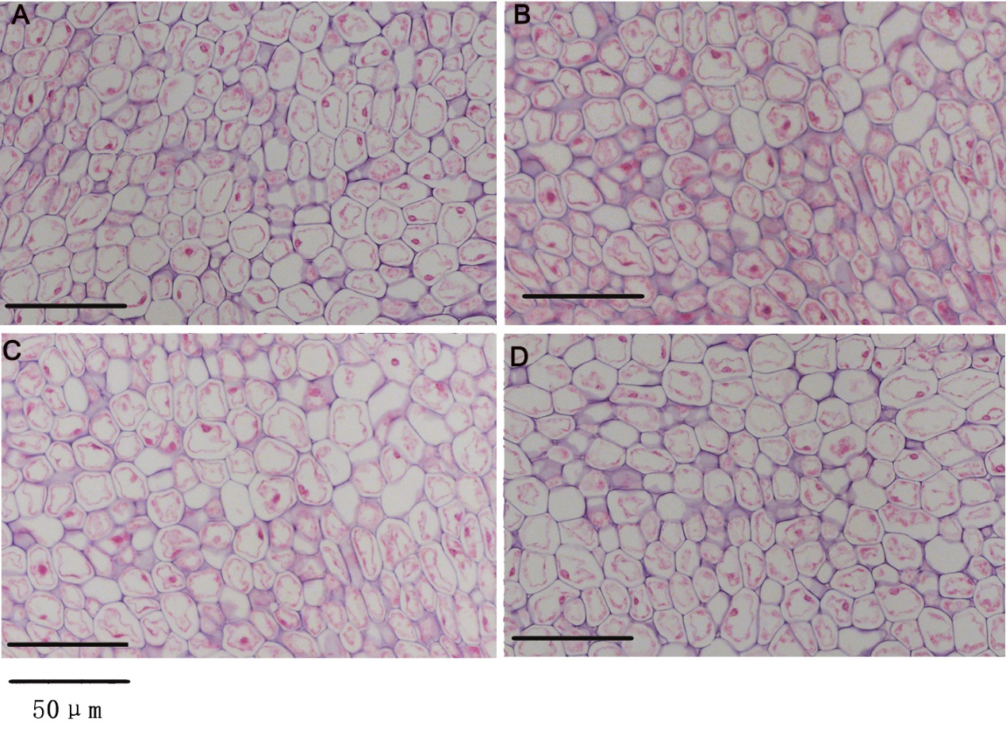
Fig. S1 Fruit tip tissue sections of EC1(A),8419s-1(B), IL52(C), CCMC(D). The average size of cells has no significant differences in in the four inbred.

